Dang Quoc Lam

15 years old – Group 1

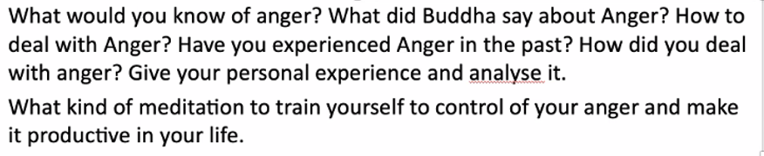

Anger is an unnecessary human emotion, anger makes us lose control and can do foolish things. Sometimes anger can kill us and the people around us, making them even more alienated from us. The Buddha said that beware of the anger of the mind, and control the mind. The Buddha also said that leaves the sins of the mind and practice virtue with the mind. The Buddha have said about how to deal with anger. For example, “overcome the angry by non- anger, overcome the wicked by goodness, overcome the miser by generosity, overcome the liar by the truth”. In the past, I have experienced about anger many times. After going to the temple to bow to the Buddha and consult with the monks, I found a way to free myself from anger by reading books and listening to music and those things make me so much less stressed and make me love life more. The Buddha reminded us to not be angry, calm down when we are angry no matter the reason right or wrong. People must know that when we are angry our mind cannot calm down and we will bring the affliction to people. The Buddha said that: calm down so we don’t bring affliction to yourselves. Normally, when somebody is angry, he or she often wants to punish the opponent severely. The more anger, the greater misunderstanding, the deeper hatred, the more tragic it is, how can someone who holds a grudge to be happy. In the past when angry with me, I used to criticize someone in my mind for what they did to me. Now when I'm angry, I just keep my distance from people to calm down and slowly bring it down and let it go under my control. And that was all my experience of anger in the past and until I took this course and now I have changed.

And once again, thank you, Master Minh Tam, for teaching and interacting with us all this time