Trong - group 1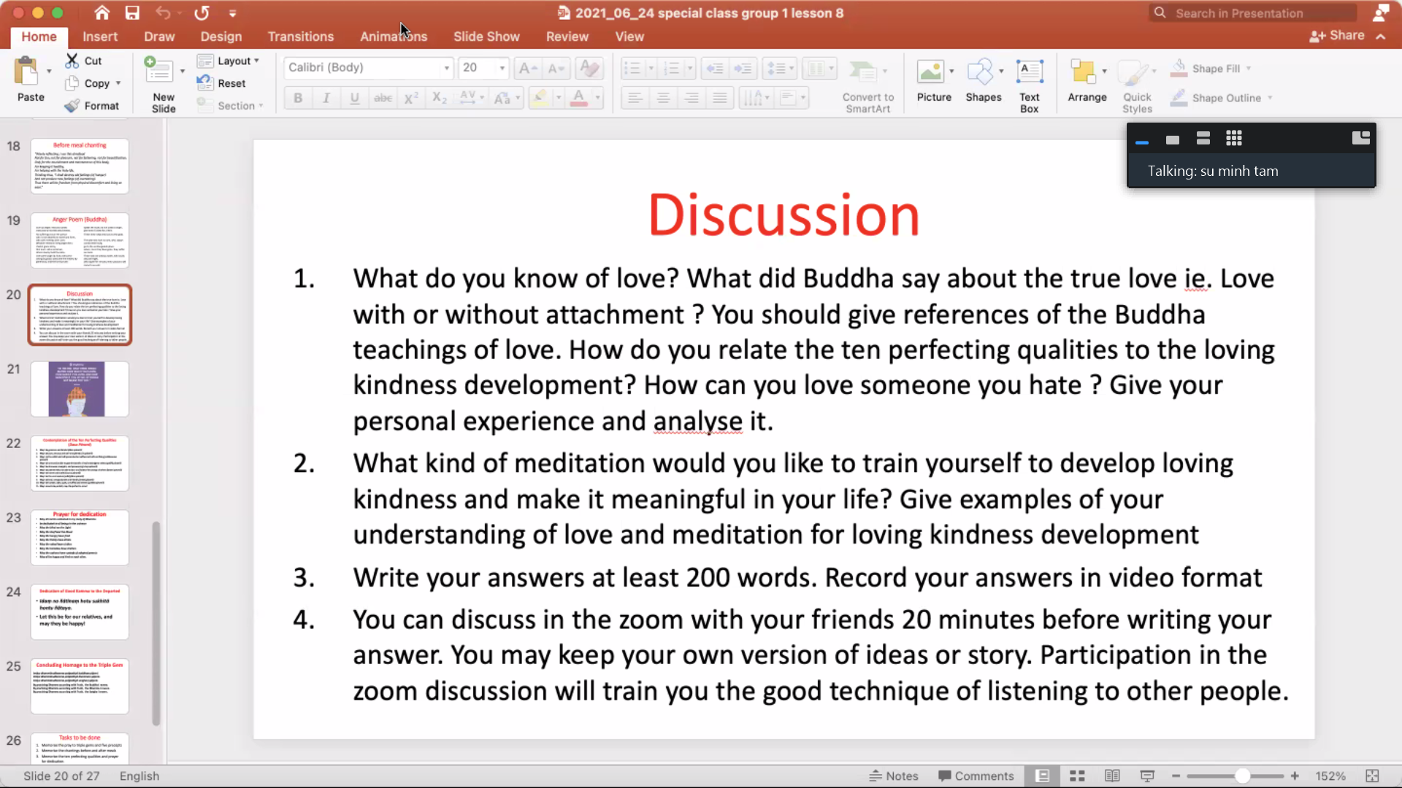

In our humans’ lives, love is indispensable. Love helps to link two different people and reproduce the next generation. That is a normal way which we will think about when we are asked about love but love is much more complex than that, it is not only to reproduce the next generation. Buddhism sees love at it’s core. There are four types of love in Buddhism: Loving kindness, compassion, appreciative joy, and a particular form of equanimity. None of these are uniquely Buddhist; they are four qualities of heart that reside within everyone, at least as potentials. Firstly, Loving kindness is not selfish love. It is the love that frees oneself from claiming. It is the sort of love that cares and nurtures like you love your family and friends,... Loving kindness is also being kind to others. Moreover, love entails compassion. This compassion is not just compassion for others, but also compassion for oneself. We need to learn to be compassionate to ourselves to fully show others love. Appreciative joy means valuing each and every second given to us. We appreciate our time here in this plane of existence. We also appreciate people around us. We also appreciate those who hurt us, because they teach us patience. Appreciative joy is the total opposite of attachment. This is the kind of happiness we draw from the small wonders given to us but not claiming them as our own. Finally, Equanimity is the state of mental calmness. It is the feeling of a still pond that reflects the sky on its surface. Equanimity allows a person to find grace and composure even in the moments of great distress. It means not being angry at people around us. Buddha talked about compassion, which is the wish for everyone around us to be happy, not focusing on whether or not we are getting what we want. This is what true love is about. Loving someone you hate is hard but if you can put an end to the hatred, things will be much easier. In particular, the hatred comes from anger and a high ego and if you conquer your anger and your conceit, the hatred will automatically fade away. In conclusion, a low ego allows us to conquer our anger, eradicate the hatred and even love someone you hate.

